## Some notes from the past: Salem Quarter News, Spring 1985

**Latest Lower Alloways Repairs**

Salem Quarterly Meeting’s appropriation of $2500 for needed repair work on our Lower Alloways Creek Meetinghouse has put the property committee well on its way to completing the work. Window framing and sills, brickwork, and the entrance support columns have been the major tasks.

The 230-year old Meetinghouse is certainly one of our most prized heritages of Quaker culture and character in South Jersey. Our investment in its preservation has been small. So very many people, Friends and non-Friends, as well as visitors, are in love with its simple beauty and meaningful history.

*- Bill Waddington.*

**Stewardship & Hancock’s Bridge**

In the years past a vision has been voiced by various Friends for Hancock’s Bridge Meetinghouse to become a retreat center for Salem Quarter. Several times it has been a gathering place for Quarter events, such as a called Meeting for Worship and a Young Friends Summer day.

Whenever a use is mentioned, the question is raised about water and bathrooms.

I suggest that we think creatively think about this gem we own, creatively and with vision. If we believe that this property could /should be viewed as an undeveloped asset for present and future Quaker activity in Salem Quarter, then surely we would easily solve the facilities problem by importing or installing them.

Let’s not continue to consign it to the category of unused meetinghouse with no resident meeting. Let’s do some brainstorming about its possibilities. I am fascinated by the thought that, as we share ideas with other PYM meetings on ways or reaching out to our own members and attenders, and as we extend a welcome to others who wish to be a part of the family of Friends, more and exciting uses for Hancock’s Bridge Meetinghouse will be conceived. Our maintaining this property is not simply to preserve an historic structure. We should see our stewardship as an investment for the future use of a growing Religious Society of Friends.

*- Judy Suplee*

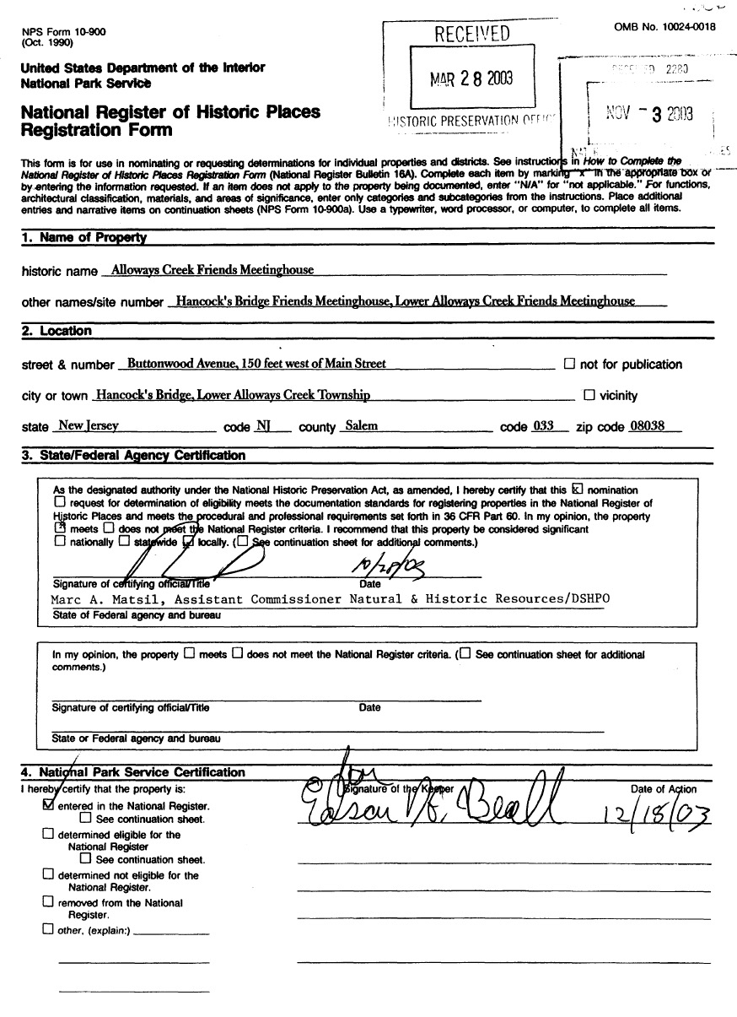

**Uses for the LAC Meetinghouse**

From our October 25, 2015 Uses Collaboration, there were two main thoughts about how the Lower Alloways Creek should be used:

1. **Active Quaker uses**
   1. Opportunities for worship or meditation both open or focused. Guided meditation.
   2. Day long retreats (i.e. PYM Worship & Care Extended worship)
   3. Regular meeting for worship, (i.e. once a month or for a full month, perhaps in the afternoon)
   4. Quarterly meetings, as part of the rotation around the Quarter
   5. Concerts/recitals by Quaker musicians and/or others
   6. Lectures on Quaker concerns, history, practices or philosophies
   7. Demonstrations of Quaker Practices
      1. Meeting for worship
      2. Weddings
      3. Memorial services
2. **An historic destination that could serve as the scene for many kinds of events**
   1. Concerts/recitals hosted/sponsored by us or others, Individual or series
   2. Lectures on history
      1. Join with scheduled events at Hancock House, either events that are part of the official (state staffed) operations or events scheduled by the Friends of Hancock House. These could range from public tour groups, school tour groups, ice cream social, or other social events.
      2. Coordinate with Smick Cabin in Canton and the other historic sites in the area.
      3. Independent events, hosted by us.
      4. Sunday Afternoon Lecture series
   3. Demonstrations or Re-enactment Programs
      1. Country Thanksgiving/ Harvest celebration / “re-enactment” with or without food available for consumption.
      2. Carriage show/ Carriage Day
         1. Concept: transportation “as it once was”
         2. Resource: Ranch Hope collection of carriages and horses.
      3. Quaker Practices (in conjunction with local Historical Society events).
         1. Meeting for worship
         2. Weddings
         3. Memorial services
      4. Potential need: Quaker costumes (reach out to Salem and Woodstown, other meetings, to borrow as needed)
   4. Friends of Hancock House meetings and lectures
   5. Events as presented by rental groups
   6. Opportunities for astronomy groups
      1. Concern: existing light pollution
   7. Activity Based Community Events
      1. Treasure Hunt
      2. Easter Egg Hunt
      3. Scavenger Hunt
      4. GEO Cache site
      5. Salem County Arts Group “Day of Art” similar to the Fellowship of Quaker Artists event.
      6. “Arts in Bloom” location for artists who don’t have their own studio)
3. Do what other groups don’t do.
4. Historic destination. Why is it special? South Jersey Quakers. Third oldest meeting in West Jersey (1679, after Salem (1675) and Burlington). Acknowledge the historic significance of the meetinghouse as driving the desire to preserve it by putting it to wider uses.

**Concerns to address**

Fragility of building, code requirements; ADA accessibility; handling of costs/ admission charges; use of partial indoor space for display purposes with restoration at conclusion of the event, need of rental group to provide insurance

**Potential needs**: lighting, heat, restrooms, prepared curriculum. Establish a “Friends of the LAC Meetinghouse” group.

**Resources**: 2001 Black Binder Survey (county/ state survey) located at the State Historic Preservation office in Trenton. No known local copies. LAC Historic District: patterned brick houses, Hancock House, LAC Meetinghouse.